**PROJECT DESIGN PHASE II**

Data Flow Diagram & User Stories

|  |  |
| --- | --- |
| Date | 15 October 2022 |
| Team ID | PNT2022TMID30076 |
| Project Name | Project – SMART FARMERS USING IOT |
| Maximum Marks | 4 Marks |

**Data Flow Diagrams:**

A Data Flow Diagram (DFD) is a traditional visual representation of the information flows within a system. A neat and clear DFD can depict the right amount of the system requirement graphically. It shows how data enters and leaves the system, what changes the information, and where data is stored.

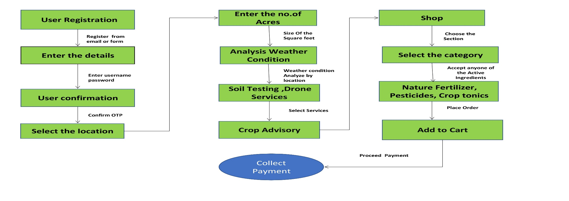

**User Stories**

Use the below template to list all the user stories for the product.

| **User Type** | **Functional Requirement (Epic)** | **User Story Number** | **User Story / Task** | **Acceptance criteria** | **Priority** | **Release** |
| --- | --- | --- | --- | --- | --- | --- |
| Customer (Mobile user) | Registration | USN-1 | As a user, I can register for the application by entering my email, password, and confirming my password. | I can access my account / dashboard | High | Sprint-1 |
|  | Confirmation | USN-2 | As a user, I will receive confirmation email once I have registered for the application | I can receive confirmation email & click confirm | High | Sprint-1 |
|  | Register by Facebook | USN-3 | As a user, I can register for the application through Facebook | I can register & access the dashboard with Facebook Login | Low | Sprint-2 |
|  | Registered by Gmail | USN-4 | As a user, I can register for the application through Gmail | I can register &access the dashboard with Gmail Login | Medium | Sprint-1 |
|  | Login | USN-5 | As a user, I can log into the application by entering email & password | I can receive confirmation email & click confirm | High | Sprint-1 |
|  | Dashboard | USN-6 | Describe how a user should interact with the System | I can access particular user data | High | Sprint-1 |
| Customer (Web user) | Home | USN-7 | A web user can login into the google account & Mobile number with Verification code | I can access all the user data | High | Sprint-2 |
| Customer Care Executive | Chat Box | USN-8 | As a user have any Quires you can text through the Chat Box it’s User Friendly | I can access the User Quires | High | Sprint-1 |
| Administrator | Database management System | USN-9 | A User details once process through the Application it all stored More Securable in DBMS | I can store the user data in DBMS | High | Sprint-1 |
|  |  |  |  |  |  |  |
|  |  |  |  |  |  |  |
|  |  |  |  |  |  |  |